

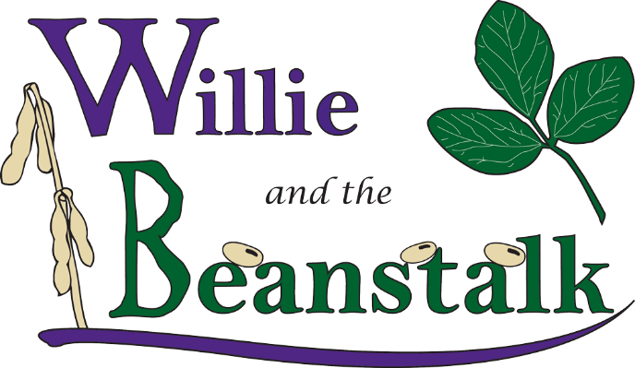

*http://beanstalk.agronomy.ksu.edu*

*Manhattan, Kansas*

**WILLIE and the BEANSTALK**

**All University Open House Plant Growing Contest**

Sponsored by **Kansas State University Department of Agronomy**

***Willie and the Beanstalk*** is a contest is open to high school, middle school, elementary school, 4-H, and/or FFA teams interested in the   
scientific principles surrounding plant growth. The challenge is to grow the largest soybean plant in a 40-day time

span and document this effort.

Beginning on a common seeding day, contestants will grow a soybean plant for 40 days, and document their activities. Entries can be scored by their adviser or plants can be submitted to the Department of Agronomy in Throckmorton Hall during Kansas State University Open House for scoring. Prizes will be awarded for the top entries in each judging category and all entrants win a tee shirt. Questions about the contest should be sent to [beanstalk@ksu.edu](mailto:beanstalk@ksu.edu).

**2025 Contest Rules – NEW changes on judging, please read carefully**

The contest has four components:

1. Pre-contest entry form
2. 47-day plant growth period
3. Written documentation of cultural practices (form available on-line)
4. Judging of plants and written material by K-State Agronomy Department or remotely by students and advisers.

Contest forms and rules are available at: <http://beanstalk.agronomy.ksu.edu>

**I. Contest Entry**

The contest is open to 3-person teams of K-12 students living in Kansas. **The contest will have two divisions, K-8th grade, and 9th – 12th grade.** Each team should select a name for their group and prominently display that name on their entry. Multiple team entries from schools and organizations are encouraged, however, students can only participate on one team. Three-person teams are encouraged, however teams with less than three students are allowed if an organization has an insufficient number of students to create complete 3-person teams. Contestants cannot participate on more than one team. **Deadline for submitting an entry form at the contest website is February 24, 2025.**

**II. Growing Period**

1. Planting Date: For K-State Open House contest, hosted on April 12, 2025, seeds can be planted no sooner than February 24, 2025 (i.e. 47 days preceding Open House). Contestants and a team adviser must attest to planting date on the entry form. Note, seeds can be germinated and transplanted to the rooting medium, but the germination/soaking process cannot start prior to February 24, 2025.
2. Seed source: contestants may select any Soybean variety/cultivar (*Glycine max)* for this contest. Select your seed source carefully as it can greatly influence plant growth. Full cultivar name and source must be included in the Cultural Practices Documentation Form.
3. Pots used for growing plants must be less than or equal to 6” in diameter and less than or equal to 10” deep. Pots can be of any material.
4. Select your soil/rooting medium carefully as the root environment has a large impact on plant growth. The physical and chemical composition of the media must be described in the Cultural Practices Documentation Form.
5. Select amendments to the soil/rooting medium (fertilizers, etc.) that will optimize plant growth. Note: materials classed as growth hormones are not allowed in this competition. Types, amounts, and dates of amendment use must be described in the Cultural Practices Documentation Form.
6. Select a lighting and temperature environment to maximize growth. Do not underestimate the effects of lighting and temperature. Lighting and temperature conditions must be described in the Cultural Practices Documentation Form.
7. Maintain a watering regime designed for maximum growth. Describe this regime in the Cultural Practices Documentation Form.

**III. Cultural Practices Documentation Form** (available on-line at <http://beanstalk.agronomy.ksu.edu>**)**

1. Keep a record of all cultural practices used in the contest. Record should be **very** detailed. Please visit the website for further instructions on the information that should be included with this form.
2. **Submit an electronic copy of your Cultural Practices Documentation Form before 5:00 p.m., March 28th, 2025** to allow for judging (see website for details).

**IV. Contest Judging**

**Entries can be scored by the students and adviser on or before April 12, 2025 (remote judging) OR they can be delivered to the K-State Manhattan Campus Open House (room TBD) on Saturday, April 12, 2025between 9:00 AM and 12:00 PM for scoring (in-person judging).** All entries (for both in-person and remote judging) will be scored on the same criteria. The scoring will be for a single plant still growing in its pot.

1. Entries will be scored based on 5 criteria, see on-line instructions for remote scoring of items 2 through 5:
   1. Cultural Practices Documentation will be scored from 0-100 points. Scoring will be based on completeness, accuracy, adherence to rules, and creativity in plant husbandry. All entries (both remote and in-person scoring) must submit the documentation form one week prior to the judging date (March 28th, 2025).
   2. Plant height (cm) will be measured at the highest leaf point above the soil surface with no leaf extension (plants can be staked).
   3. Number of fully developed trifoliate leaves will be counted.
   4. Plant mass will be the wet weight (g) of the plant cut off at the soil surface.
   5. Leaf area (cm2) of the largest trifoliate leaf will be measured.
2. Results for remotely scored entries will be submitted through our website on or before April 12th, 2025.
3. Teams will be separated into two divisions (K-8 and 9-12). Plants within each division will be ranked based on the above criteria. Top ranked soybean plants in each criterion will receive an award.

An overall contest winner will be determined in each division (K-8 and 9-12) based on the sum of their ranks for each criteria. For example, a team that had the best documentation, the 5th tallest plant, the 3rd greatest number of trifoliates, 8th greatest biomass, and 4th largest trifoliate would have the following final score: Final Score = 1 + 5 + 3 + 8 + 4 = 21. The team with the lowest overall final score will win the contest. Ties will be broken by the lowest scores in the individual categories in the following order: documentation, biomass, height, leaf area, and leaf number.

Thank you to our sponsor,   
The Kansas Soybean Commission

*http://beanstalk.agronomy.ksu.edu*